TEAM ID: PNT2022TMID08163

PROJECT NAME: DemandEst - AI powered Food Demand Forecaster

# Team Leader

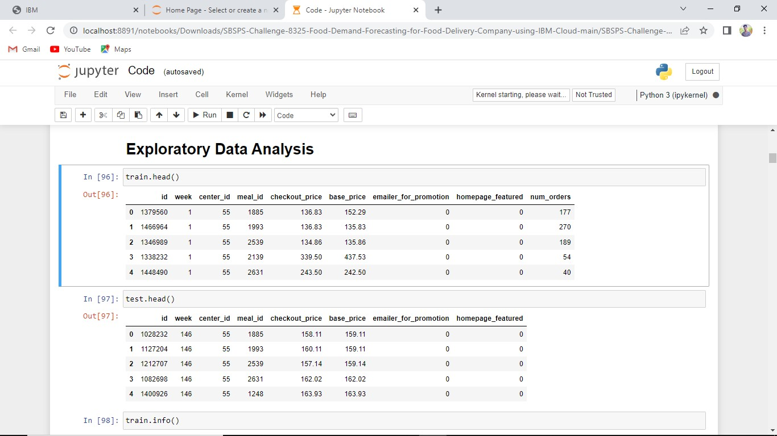

# Team Member 1

# Team Member 2

# Team Member 3

